Riparian Buffers Name:

A riparian area is that area of land located immediately next to streams, lakes, or other surface waters.

Introduction
Over a third of our nation's streams, lakes, and estuaries are impaired by some form of water pollution (U.S. E.P.A. 1998). Pollutants can enter surface waters from point sources, such as single source industrial discharges and waste-water treatment plants; however, most pollutants result from nonpoint source pollution activities, including runoff from agricultural lands, urban areas, construction and industrial sites, and failed septic tanks. These activities introduce harmful sediments, nutrients, bacteria, organic wastes, chemicals, and metals into surface waters. Damage to streams, lakes, and estuaries from nonpoint source pollution was estimated to be about $7 to $9 billion a year in the mid-1980s (Ribaudo 1986).

Riparian buffers are vegetated areas next to water resources that protect water resources from nonpoint source pollution and provide bank stabilization and aquatic and wildlife habitat.

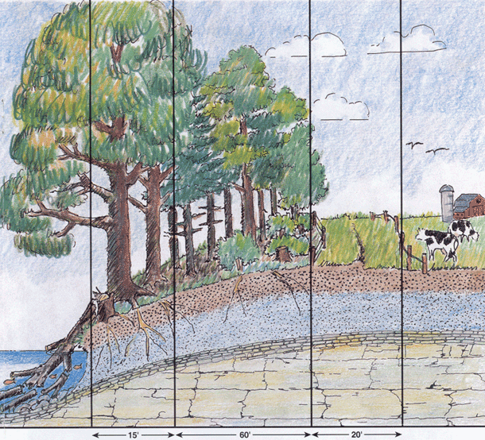
Trees and plants filter out pollution and prevent soil erosion!

How many of Union County’s streams still have riparian buffers?

Procedure:
- Choose any stream found on the Lewisburg Quadrangle contour map.

- Use a string and a ruler to determine the length, in inches, of this stream.

Total length in inches:

Convert this to miles:

- Now measure how many inches of this stream has a forested area on both sides of the stream (in green).
Must be forested on both sides of the stream to count.
Forested area must touch the creek.

Riparian length in inches:

Convert this to miles.

- What percent of your stream still has a riparian buffer zone? (riparian miles / total miles x 100 )

- Much of Union County land is owned by private individuals, in other words not government land. What can be done to restore some of the riparian buffer zones along your creek? Give some specific ideas that would encourage people to restore buffers on their land.

